assignment #07

Course: CHE 341: Chemical Process Control
Term: Spring 2026
Professor: Dr. Michael Caracotsios
Office: EIB 244

Cell Phone: (630) 696-0934
E-mail: mcaracot@uic.edu

Name: ________________________
Due Date: Tuesday, May 5th in Class

INSTRUCTIONS FOR ASSIGNMENT DELIVERY

- Prepare a typed report of your assignment.
- Include this cover page with your name in the report.
- Upload your report as a PDF file by the Due Date and Time(6:00PM) on the UIC Blackboard.
- Place a hard copy of your report as a PDF file by the Due Date and Time(Closing of the Business Day) in the TA’s mailbox.

- Assignments that are not typed will not be accepted.
- Late Assignments will not be accepted without prior approval.
- You may use the Internet as well as ChatGPT or other public tools as long as you place a written statement about their use in your assignment report

Problem 1: Feedback Control of a Thermal System

Consider the thermal system shown in the simplified process diagram below:
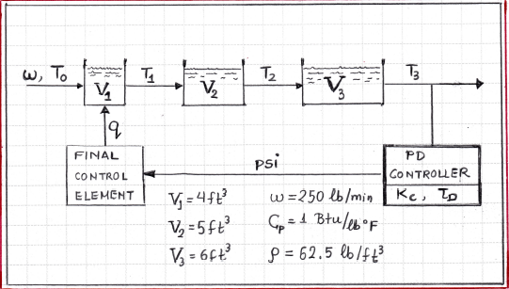

The thermal system is currently being controlled by a Proportional Derivative (PD) controller with gain and rate equal to: The temperature of the inlet stream is considered a disturbance.

- Draw a block diagram of the control system with the transfer functions in each block. Each transfer function must only have the numerical values of its parameters.
- From this block diagram, determine the closed loop transfer function relating the temperature in tank #3 to a change in the set point.
- From this block diagram determine the closed loop transfer function relating the temperature in tank #3 to a change in the inlet temperature
- Calculate the offset for a unit step change in the inlet temperature
- Perform a simulation using the CHE Calculator.xlsm Excel tool to verify your theoretical answer in question #4.
- You have been asked to eliminate the observed offset. Design a controller and calculate its parameters that would accomplish just that. Perform a simulation again, using the CHE Calculator.xlsm Excel tool to verify that the observed offset has been eliminated.
- Calculate the settling time and present it along with the controller parameters in a Table included in a separate page in your final report. Your final report should also include the graphical results for questions #5 and #6.

Problem 2: Feedforward Control of a Distillation Column Tray Temperature

The temperature of a critical tray in a fractionator will be controlled by employing a Feedforward controller as indicated in the diagram shown below.
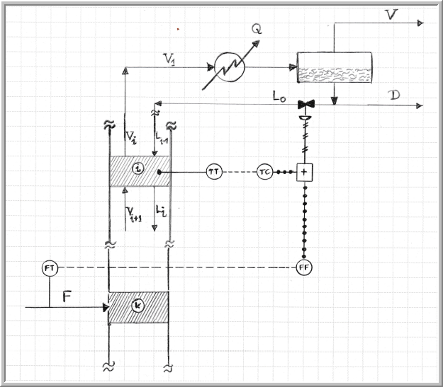
Using the appropriate step tests the following individual transfer functions models were obtained for the response of the tray temperature to (1) feed changes and (2) reflux flow rate changes:

(Equation 1)

- Design a Feedforward controller to achieve perfect disturbance rejection and show in a control block diagram how it would be implemented. Is the Feedforward controller realizable?

Consider the situation in which the model is inaccurate with the actual model process given by:

(Equation 2)

- Using the Feedforward controller designed in part (a) simulate and plot the response of the temperature under a Feedforward control to a step change of DS=2 in the feed flow rate
- Design a Feedback controller for this process using direct synthesis with a . In the design, use the parameters of the model assumed to be correct and given in Equation (1). Apply the Feedback controller to the actual process without using the Feedforward controller and simulate the closed loop response to a step change of DS=2 in the feed rate (disturbance)
- No apply to the actual process (Equation 2) a Feedforward-Feedback control scheme using the Feedforward controller designed in (a) and the Feedback controller designed in (c). Simulate the closed loop response to a step change of DS=2 in the feed rate (disturbance)
- Show all three response curves in a single graph and verify whether the Feedforward controller performs as expected.

